Beyamarr 1 Munungurr
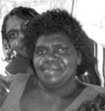
Born 1963
Region Arnhemland
Language Yolngu

Biography

Beyamarr’s father was well known artist Djutjadjutja Munuŋgurr, deceased in 1999. Beyamarr continues to live and work as an artist at the Djapu clan outstation of Waṉḏawuy. She is a mainstay of that community. Her art remains strictly within her clan template.
Clan: Djapu, Balamumu
Homeland: Wandaway/ Buku—dal/Garrtha
Moiety: Dhuwa

