Janet Evari
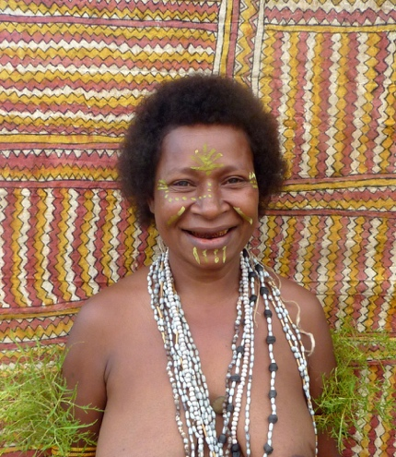

Birth Year c.1977
Language Group Omie
Region Papua New Guinea

Biography

Janet was born at Asapa village. Her father is Walter Ranu, and her mother is Susan Bujive. Although she was born into the Emate clan. Her mother was originally born into the Sahuote clan and taught her a wealth of Sahuote clan designs. Janet often paints important Sahuote clan designs including buboriano’e, beaks of the Papuan Hornbill; dahoru’e, Ömie mountains; and visuan’e, teeth of the river fish. She is married to Hillary Evari and together they have seven children.

Exhibitions

2021 Spirit in Bark: A Celebration of Bark Art from Across Oceania (group exhibition with Maningrida Arts & Culture and Elcho Island Arts), Koskela, Sydney, Australia

