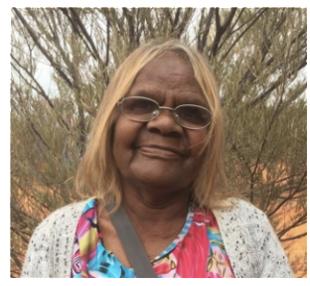
Wanatjura Lewis

Born c. 1952
Language Pitjantjatjara
Region Anangu Pitjantjatjara Lands, SA

Biography

Wanatjura Lewis was born in 1952 in Ernabella (Pukatja) in the remote Anangu Pitjantjatjara Yankunyjatjara Lands in north-western South Australia, and is the daughter of leading Ernabella artist, Tjulkiwa Atira-Atira. Her mother’s country is Kunamata and her father’s country is Pipalyatjara. Wanatjura moved to Amata with her family when she was ten years old. Wanatjura first worked with batik at Ernabella, before taking up painting at Tjala Arts (formerly Minymaku Arts). Wanatjura depicts the Seven Sisters and Wanampi Tjukurpa (creation stories), as well as inma in her richly detailed canvases. Wanatjura is a dedicated painter at Tjala Arts, and has previously served on the Board of Directors. Wanatjura's mother was a basket maker, and she has also learned weaving skills from the senior artists in her community; Ilawanti Ken, Nyurpaya Kaika Burton, Naomi Kantjuri. Wanatjura gained her confidence and interest in tjanpi through assisting these senior women in their large-scale exhibition works. She produces tightly woven beautiful baskets with particular care taken with the use of soft colours. Wanatjura says she is happy to learn more about weaving. Together with her career as an artist, she is also a Director with the NPY Women’s Council, and is regarded as an important leader and teacher in the community more broadly.

Tjanpi (meaning ‘dry grass’) evolved from a series of basket weaving workshops held on remote communities in the Western Desert by the Ngaanyatjarra Pitjantjatjara Yankunyjatjara Women’s Council in 1995. Building on traditions of using fibre for medicinal, ceremonial and daily purposes, women took easily to making coiled baskets. These new-found skills were shared with relations on neighbouring communities and weaving quickly spread. Today over 400 women across 28 communities are making baskets and sculptures out of grass and working with fibre in this way is firmly embedded in Western and Central desert culture. While out collecting desert grasses for their fibre art, women visit sacred sites and traditional homelands, hunt and gather food for their families and teach their children about country. Tjanpi Desert Weavers is Aboriginal owned and is directed by an Aboriginal executive. It is an arts business but also a social enterprise that provides numerous social and cultural benefits and services to weavers and their families. Tjanpi’s philosophy is to keep culture strong, maintain links with country and provide meaningful employment to the keepers and teachers of the desert weaving business.

Group Exhibitions

2020 Songlines: Tracking the Seven Sisters
2019 Before Time Began: Contemporary Aboriginal Art
2002 Art-rium, Graz, Austria - Exhibition of Aboriginal Art
2002 Mossenson Gallery – Indigart, Perth - Limited edition Prints of Minymaku

