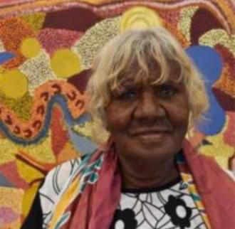
Gracie Green

Birth Year 1949
Region Fitzroy Crossing

Biography

Grace Green was born in Billaluna Station. Her parents came from the desert in the 30’s or 40’s from country called Kartamarnti.

She later grew up at Balgo mission, where she attended school and during the school holidays her family would tell her stories of how they lived off the land.

In this way she also learnt the dreamtime stories of her mother’s and father’s country, it makes her happy that she can paint these stories.

“I always tell my children about their grandmother and grandfather Country and now my daughter is following in my footsteps.”

